MEDICAL GASES
Definition
Medical gases – Are those gases that are inhaled by a patient as directed by doctor. They may exist in gas form or in liquid form. They may be delivered from small cylinders (or bottle) or piped from a central source.
Examples of these gases are:
- Oxygen - O₂
- Nitrous Oxide - N₂O
- Entonox - N₂O + O₂
- Medical air – Mixture of gases
- Cyclopropane - C₃H₆
- Carbon-dioxide - CO₂
Terms used in administering the gases
- Anesthesia gases – These gases cause loss of feeling or sensation in the body. It is used for general anesthesia ie total unconsciousness
- Sedative gases – gas that relax mind.
- Analgesic gases – These are the gases used to relieve pain ie they may cause analgesia ie reduction of sensitivity to pain without loss of consciousness.
- Life support gases – these are gases that support life eg oxygen.
- Respiratory assisting gases – Forces patient to breath, acts as a stimulant.
Risks involved while handling medical gases
- High pressure risks
- Confusion due to improper identification.
- Fire and explosion risks for combustible

Q ₁.
Explain how the above risks can be solved (10mks)
Safety storage and handling of the cylinders.
Storage
- Cylinders should be stored under cover in a clean, dry and well ventilated environment.
- They should not be exposed to extreme heat or cold.
- Should not be allowed to become wet, dirty or rusty.
- Should not be near combustible materials or where there is high risks of fire.
- They should be stored vertically for large cylinders; small cylinders can be stored horizontally on a wooden shelf.
- Misidentification of cylinders can be eliminated by ensuring that repainting is only done at the manufacturers premises
- A very slow leaks can be suspected by loss of pressure when no gas is being used. This can be confirmed by using soapy water applied onto the suspected joints or valves.
- Cylinder valves leaks should not be repaired; the cylinder must be returned to the manufacturer at once.
NOTE:
Manifolds- it is the connection used at the central medical gas supply for connecting O₂ or N₂O cylinders in a bank.
- It should be looked after by one person to ensure safety
- Empty cylinders should be replaced immediately
- Manifolds means various inlet and only one outlet.

Activities carried by the central medical gas supply in-charge
- Keep the key for the store
- Keep the records – daily records of the occurrence
- Check leaks at the joints
- Record the cylinder pressures
- The functional of the alarm systems.
Alarm systems in the central medical gas
- Leak detectors
- Smoke detectors

Safeties
- Avoid combustible materials or source of ignitions.
- Use sparkles switches

Importance of central medical gas supply and pipeline
- It provides safe, convenience means of distributing medical gas, medical compressed air and vacuum for various clinical and an aesthetic purpose.
- The provision of pipeline avoids the necessity of large number of cylinders being required in clinical areas. Except for few emergency and back up cylinders and portable suction devices.

General use of the following medical Gases
Oxygen – Life support, respiratory therapy and anesthetic procedures
Medical Air – It is only used in respiratory therapy as a power source for patient ventilators and for blending with oxygen.
- Sometimes is referred to surgical air- in higher pressure can be used to power variety of surgical tools.
- It is also used for driving gas for nebulized drugs and chemotherapy agents.

Nitrous Oxide (N₂O) – it is used for anesthetic and analgesic purposes.
Vacuum – central vacuum systems or portable suction.
- Used for suction of unwanted fluids for the patient.
Carbon dioxide CO₂ - it is used to stimulate respiratory Centre.

Gas cylinder manifolds installations
- Gases are supplied to the wards via the central gas supply, this is done through the manifolds (O₂ and N₂O)
- It is important that they are connected through manifolds ie banks of cylinders.
- Oxygen and Nitrous oxide, manifold should be connected in equal banks.
- Each cylinder must be connected to a pressure regulator, non-return valve and pressure gauges.
- Alarm systems should be provided to shoe the following
- Less gas
- System failure
- Electricity supply should be carried out accordance to the T.E.E regulations. The supply should be taken from separate circuit from distribution board.
- Pipeline should be bounded to consumer earth terminal
- Smoking, welding and naked lights are prohibited within or near manifolds.
- Fine detection systems should be installed in this room.
- Oil, grease and any other combustible or petroleum products should not be used on the gas pipeline or valves, joints, gauges and regulators.
Medical Gases Accessories
- Regulators
- Flow-meters
Basic block diagram for the medical gas system supplies.

Patient
Flow-meter
Regulator
Cylinder

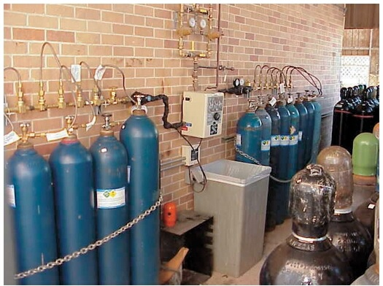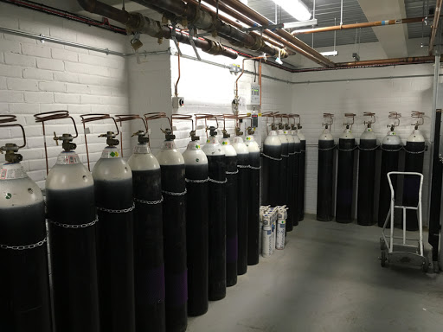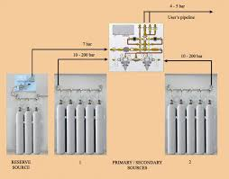
NOTE: Refer to notes on Regulators and flow-meters

Medical Gases color coding
Oxygen (O₂) | Black and white color
Nitrous Oxide (N₂O) | Blue and white color
Carbon dioxide (CO₂) | Grey
Medical Air | Grey
Vacuum | Yellow
Entonox | Blue
Cyclopropane | Orange

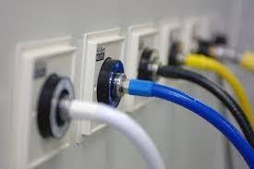
NOTE THE COLOR CODING DIFFERS WITH COUNTRY OF ORIGINS
Manufacture of Medical gases
- Oxygen (O₂)
- Fractional distillation of liquid air
- Electrolysis – Separation of Hydrogen and oxygen compounds
- Oxygen concentrators
- Nitrous oxide (N₂O)
- Thermal decomposition of ammonium nitrate.
- Carbon dioxide (CO₂)
- As a byproduct gas from fermentation
- As a byproduct gas from manufacture of hydrogen.
Safeties while using combustible and explosive gases
- Proportion of flammable gases must be proportioned and within the limits of combustible
- Presence of an initiator or ignitor of gas mixture should be eliminated eg cigarrate, naked flames, Electric sparks, static discharge.

REGULATOR
Working principles of regulator
- Oxygen flows from the cylinder to the high pressure section of regulator and this reduces cylinder pressure to a valve preset at the factory.
- Pressure adjustment screw is turned clockwise to create an opening between valve and valve seat to allow gas to flow into the low pressure chamber.
- This chamber gas relatively larger volume and the pressure is drastically reduced.
- The diaphragm is capable of moving up and down altering the size of opening in response to demands placed upon regulator.
- This regulation is carried out by regulator automatically as soon as the cylinder is opened. If there is excessive pressure built above preset valve the valve pressure relief valve opens and vents to the atmosphere.
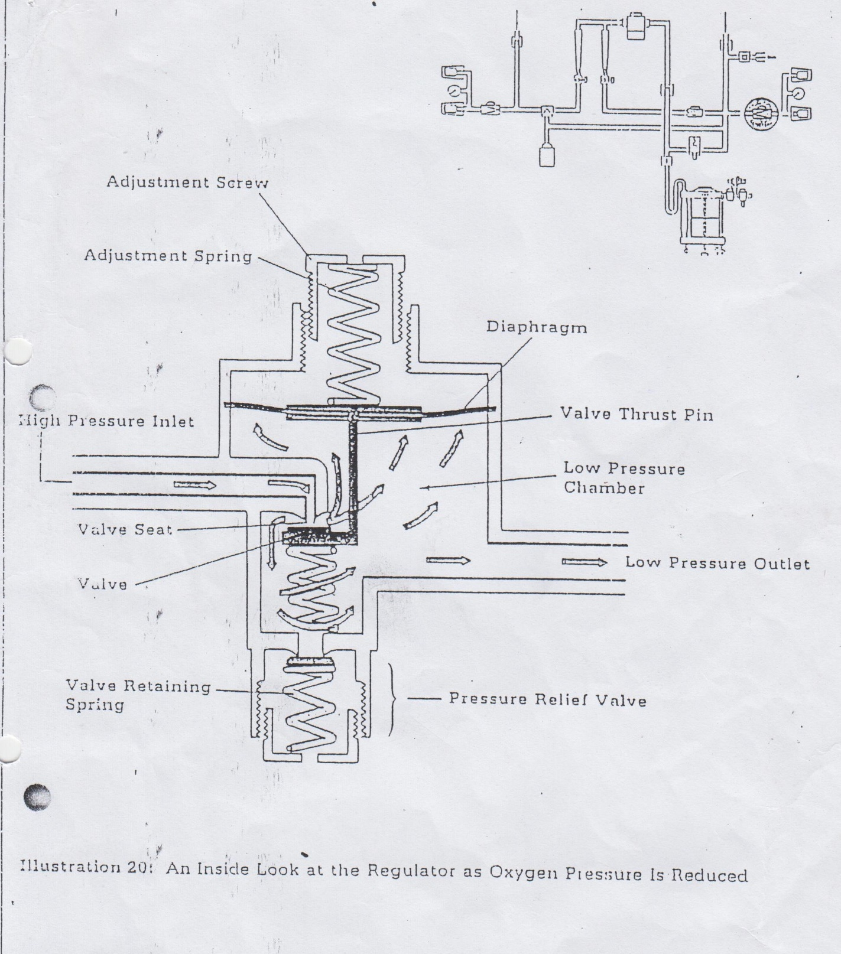

FLOWMETERS
- The function of flow-meters is to control flow of gases to the patient circuit.
- The control is done by flow control knob, turning knob closes the space between the needle and its seat.
- The flow-meter is hand calibrated system which includes tapered glass tube, throat and scale.
- It is important to note that the two flow-meters are exactly alike to compensate for the difference in flow-meter scales are individually calibrated to provide high degree of accuracy over full range of scale.

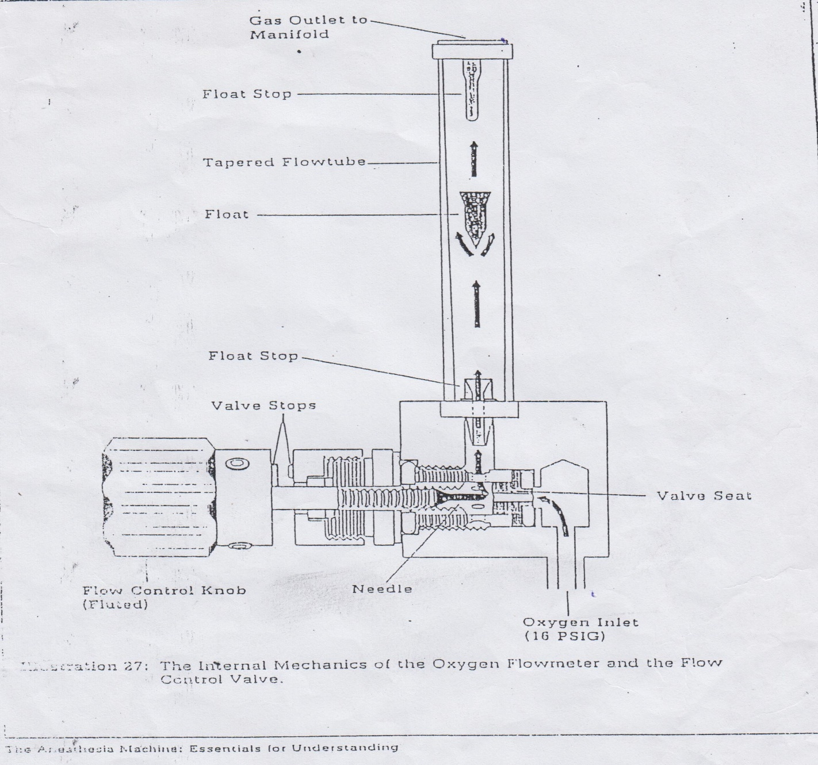

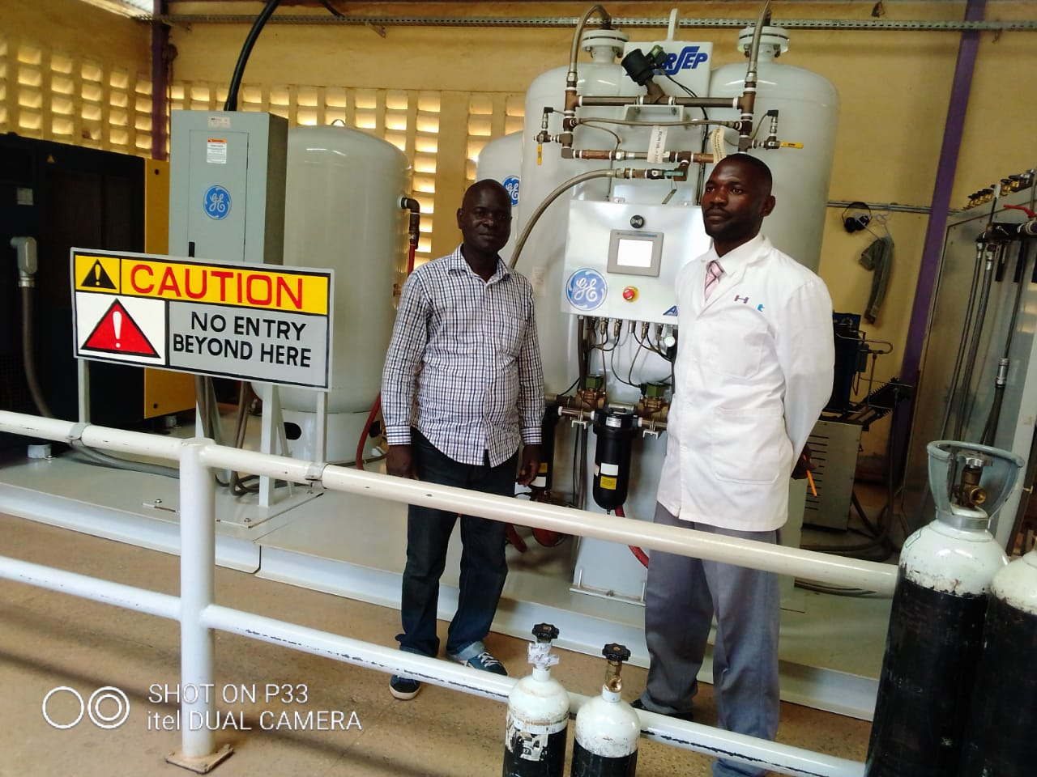
Oxygen manufacturing plant at Siaya county Hospital
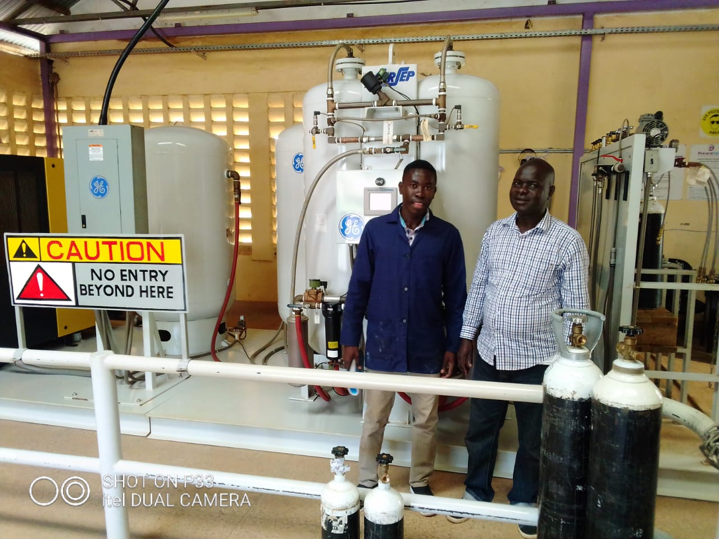

ANAESTHESIA MACHINE
Need for anesthesia
- Surgical methods of treatment consists mainly of operations which are normally carried out under some form of an aesthesia. An aesthesia serves the following two functions:
- It ensures that patient does not feel pain and minimizes patient discomfort
- It provides the surgeon with favorable conditions for the work
- When anesthesia is given so that the patient losses consciousness, it is called ‘general anesthesia’.
- In general anesthesia, the anesthetic agent is administered to the baby so that it reaches the brain via blood stream. The usual method is inhalation anesthesia in which gaseous anesthetic agents are introduced via the lungs.
- Examples of such agents are:
- Diethyl ether
- Chloroform
- Halothane
- Nitrous oxide(laughing gas)
- In the superficial stages of anesthesia, the patient can breathe for himself – spontaneous ventilation.
- At greater depth anesthesia, it may be necessary to support the patient with artificial ventilation known as controlled ventilation.
Delivery anesthesia
It consists of the following
- anesthesia machine
- Patient breathing circuit
- Ventilator
- Air way equipment
Anesthesia machine
it consists of:
- Gas supply
- Delivery unit
- Anesthetic vaporizer
Breathing circuit
It consists of:
- Closed loop breathing tubing containing two unidirectional breathing valve and an adjustable pressure limiting (APL) valve
- A CO₂ absorber
- A means of venting excess gases (scavenging)
- Humidifier
- Collapsible reservoir bag
Mechanical ventilator
Is used for positive pressure ventilation.

Air way managing equipment
- It includes the mask and endotracheal tube which interface the patient with the breathing circuit.

ANAESTHETIC MACHINE

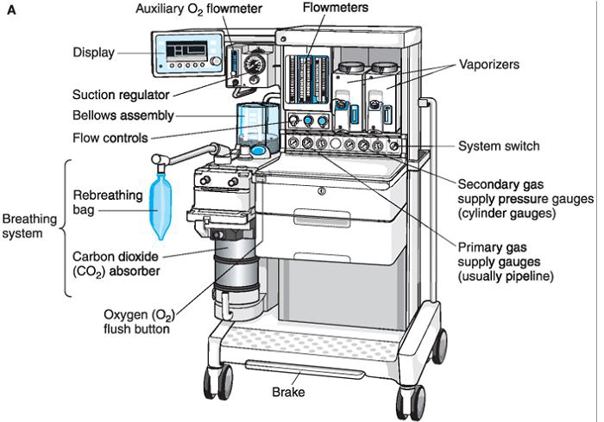

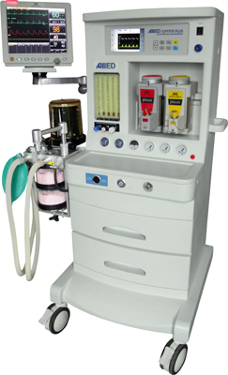

- Is a device which is used to deliver a precisely known but variable gas mixture including anesthetic and life sustaining gases to the patient’s respiratory system.
- Variable concentration gas mixture of oxygen, nitrous oxide and anesthetic vapor like ether or halothane is sustained from machine and it is made to flow through the breathing circuit to the patient.
It is composed of two systems namely:
- The gas supply delivery unit – tubing and flow meters which are interconnected
- The anesthetic vapor which is used to produce anesthetic vapor from volatile liquid.
Gas supply system
Is either from central supply or portable cylinders.
Centralized: consists of bulk or cylinder storage for main and reserve supply – control equipment ie valves, pressure regulator, distribution pipe-line and numerous supply outlets. Gas supplied is regulated and maintained at 275-345Kpa (40-50Psi) at the wall outlet.
- Gases are supplied to the anesthetic machine via central system via a flexible horse.
- In order to avoid mis-identification non-interchangeable connectors are used to each end of the horse- O₂, N₂O
- In addition to the connector design, color coded hoses for each specific gas are utilized
- Gas cylinder located in yokes attached to the anesthesia machine is also another source of gas supply.
- Yoke - most anesthesia machines are provided with two yokes for fitting O₂ and N₂O cylinders. In order to prevent during placement of cylinder in the Yoke two pins located in the yoke must fit the corresponding holes drilled into the tank neck. This identification system is referred to as “pin index safety system”. It has been standardized to prevent the accidental fitting of a wrong cylinder to the yoke.

Pressure regulator
- It reduces cylinder gas pressure to 275Kpa (40Psi) before the gas flows through the machine.

Pressure gauge
- Attached to the cylinder to indicate the contents of the gas in the cylinder. For oxygen the operating range of the gauge is 150kg/cm².
- When the indicator shows that the cylinder pressure has taken below minimum it should be replaced.
Fail safe system
- The pressure safety system will not allow nitrous oxide to flow unless oxygen supply pressure exist in the machine.

Gas delivery unit – the gas is directed to the flow delivery unit.

Vapor delivery
- The various liquid that possess anesthetic properties are too potent (strong) to be used as pure vapors.
- They are thus diluted in a carrier gas such as air and/or oxygen or nitrous oxide and oxygen.
- The device that allows vaporization of liquid anesthetic agent and mixture with carrier gas for administration to a patient is called – vaporized.
- In order to provide a stable and predictable concentration of anesthetic vapor, the vaporizers include suitable method of obtaining calibrated dilution anesthetic agents to the patient. This can be done by several means:

- Variable Bypass Vaporizers
Carrier gas flow from the flow-meter is split into streams in a known ratio: one stream which is called “chamber flow” flows over the liquid agent while the other stream goes through the bypass path and does not enter the vaporizing chamber. Final concentration can be controlled by varying the splitting ratio between the vaporizer gas and the bypass gas using an adjustable valve.
- Measured flow vaporizers
Anesthetic agent is heated to a temperature above the boiling point (gas)

Safety related inter-locks in the vaporizers
- Only one vaporizer is turned on.
- Gas enters only one side which is on.
- Trace vapor out output is minimized when the vapor is off

Delivery system
Patient breathing system:
The breathing system to deliver anesthetic and respiratory gases to and from the patient.
The breathing system can be:
- Rebreathing type
- Non-rebreathing type
- Rebreathing type: this refers to rebreathing of some or all of the previous exhaled gases, including CO₂ and water vapor.
- Non-rebreathing type: fresh gas is delivered to the patient and re-breathing of previously exhaled gases is prevented.

Circle system
- it is most popular breathing circuit
- It is closed loop with large bore of iron pressure. It is delivered into inspiratory and expiratory point
- It has got valves, a CO₂ absorber circuit gas venting (scavenging) reservoir bag, masks and endotrached tubes.
- Patients are connected to the absorber by two corrugated hoses, one inspiratory and the other expiratory
- The absorber contains a carbon dioxide absorbent (soda lime) in a closed.
- The reservoir or breathing bag is highly compliant with an easily expanded volume.

Humidification
Dry gases supplied by the anesthesia machine may cause clinically significant discretion of mucus. This may contribute to retention of secretion and the mucus flow may cease. Lung compliance may fall; therefore, air or anesthetic gases need to be humidified.
Ventilation
- An integral component of the anesthetic delivery system is the ventilator. It provides a positive force for transporting respiratory and anesthetic gases into aphetic patient
- It provides a positive pressure ventilation at a controlled minute volume.
- They separate either electrically, mechanically or pneumatically
- Ventilation is either heated within main force frame of the anesthesia machine or is attached s an accessory unit.
Patient circuit
- It consists of anti-static rubber tube, a chrome plated tube fitting, breathing bag, valves and face masks.
- Face masks are designed to fit the patients face perfectly without any leaks.

Name the parts:
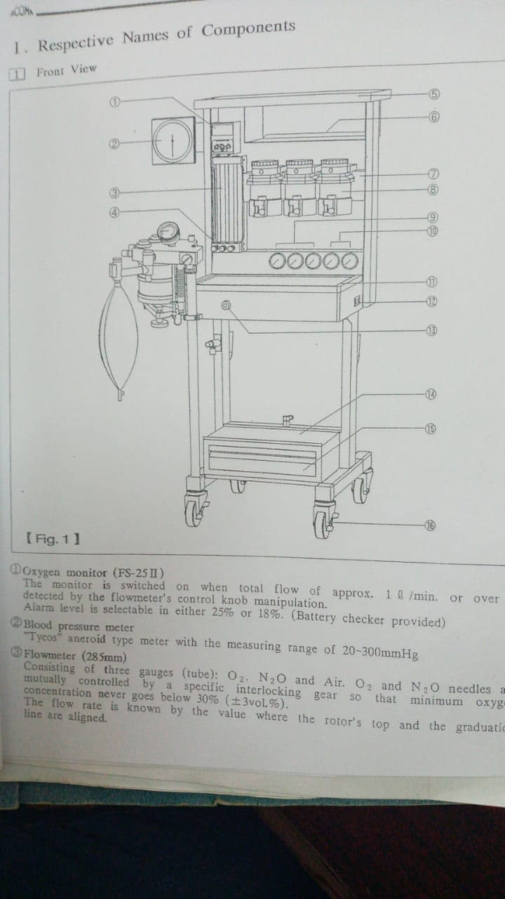
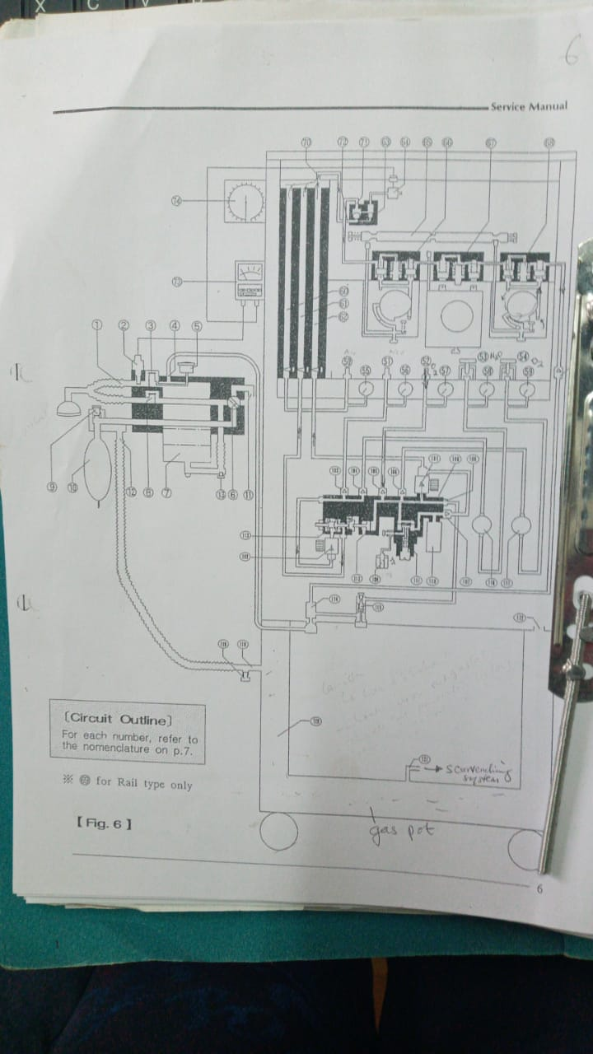
OXYGEN CONCENTRATOR
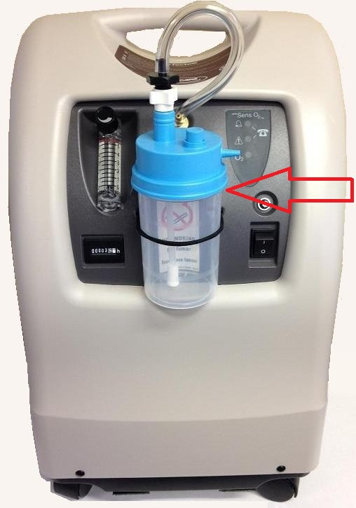

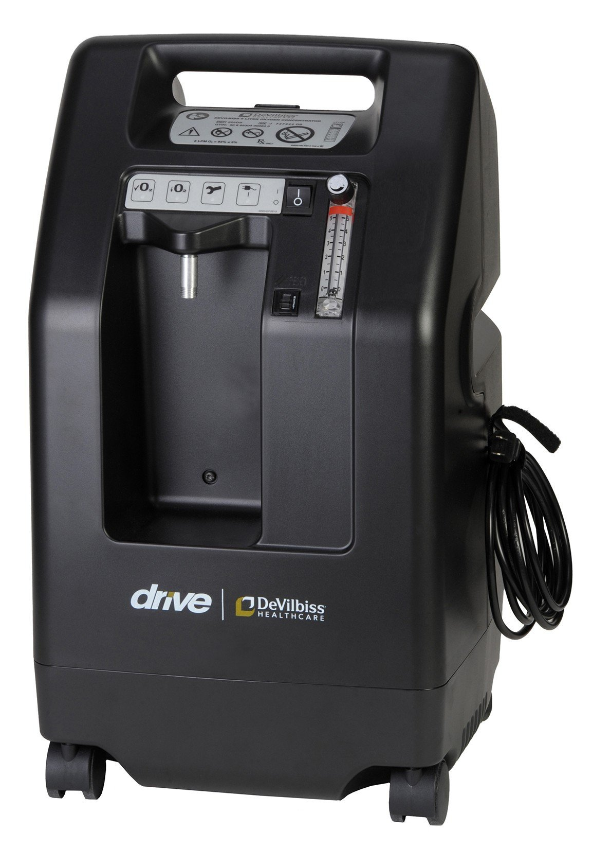
It’s also called oxygenator. It’s a medical device used to deliver oxygen to those who require it
People may require it when they are in a condition that causes or results in low levels of oxygen in their blood. In simple words an oxygen concentrator works on electricity, takes room air, removes nitrogen from it and provide up to 95% pure oxygen.
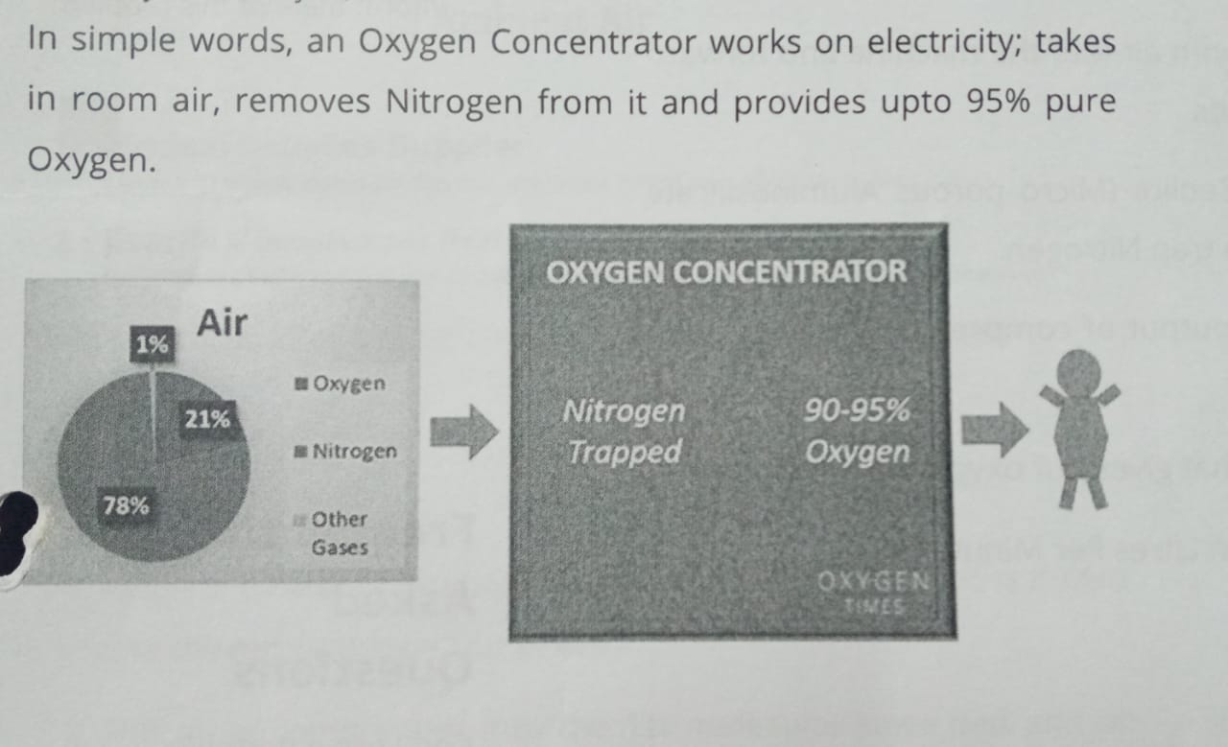

PRINCIPLES OF OPERATION
The com position of air 78%] nitrogen, 21% oxygen, 1% other gases like carbon dioxide, argon etc, clearly shows that air is mainly compressed of 2 gases, oxygen and nitrogen [99%].
If nitrogen is removed from air, the primary gas remaining would be oxygen with purity of about 90-95%.
An oxygen concentrator uses this idea with the basic principle of pressure swing adsorption to deliver 90-95% pure oxygen.
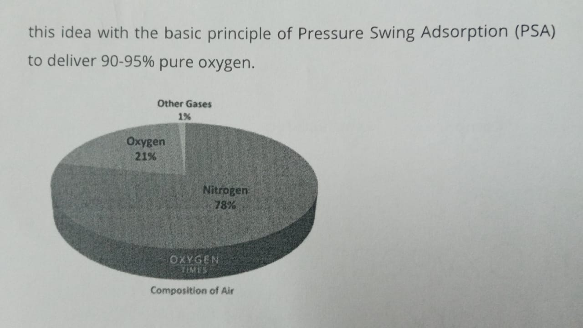

Main Components
- Series of Filters; to filters out impurities present in air
- Air compressor - to push room air into the machine and forward it to the molecular sieve beds.
- 2 molecular sieve beds- zeolite (micro-porous allumininosillicate mineral) have the ability to trap nitrogen.
- Switch valve: switches the output of the compressor between the 2 molecular sieve beds.
- Oxygen outlet – an opening that gives out oxygen to the patient
- Flow meter – to set the flow in liters per minute (LPM)
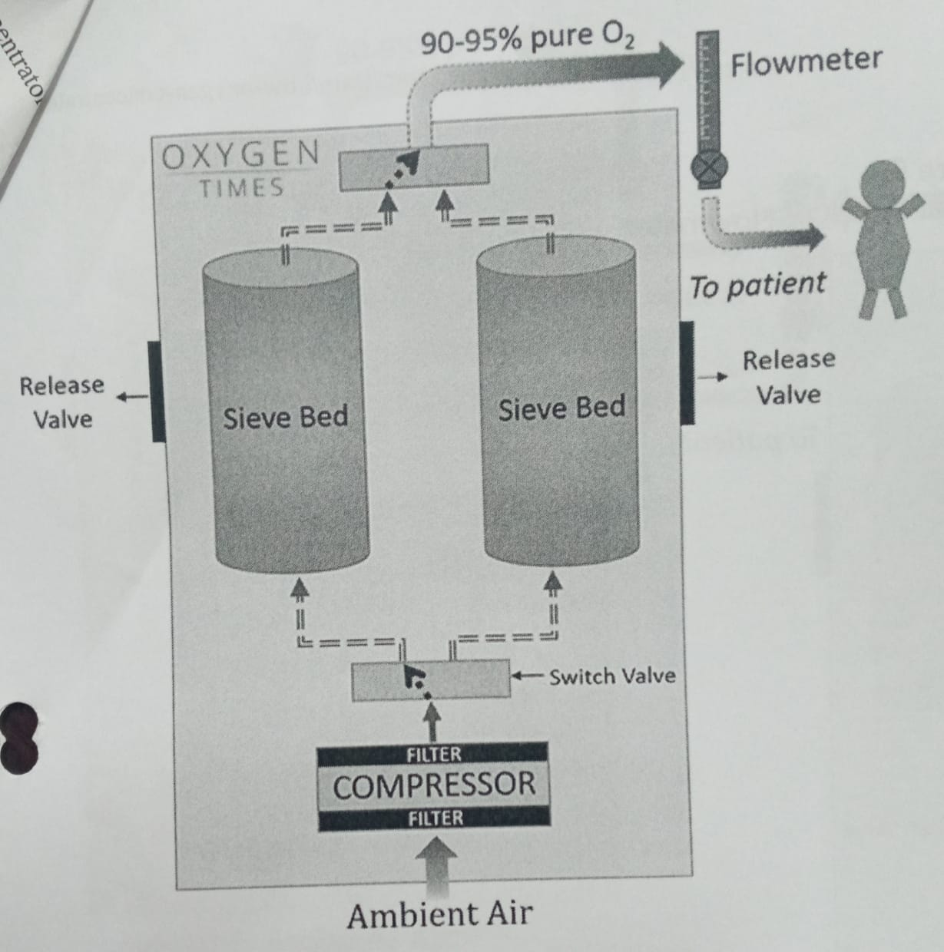
Working
- Ambient air (room air) passing through a series of filters is drawn into the machine by compressor.
- This air is compressed into 1st molecular sieve bed and all the nitrogen is absorbed. The molecular sieve beds are porous and thus have large surface area due to which they absorb large amount of oxygen.

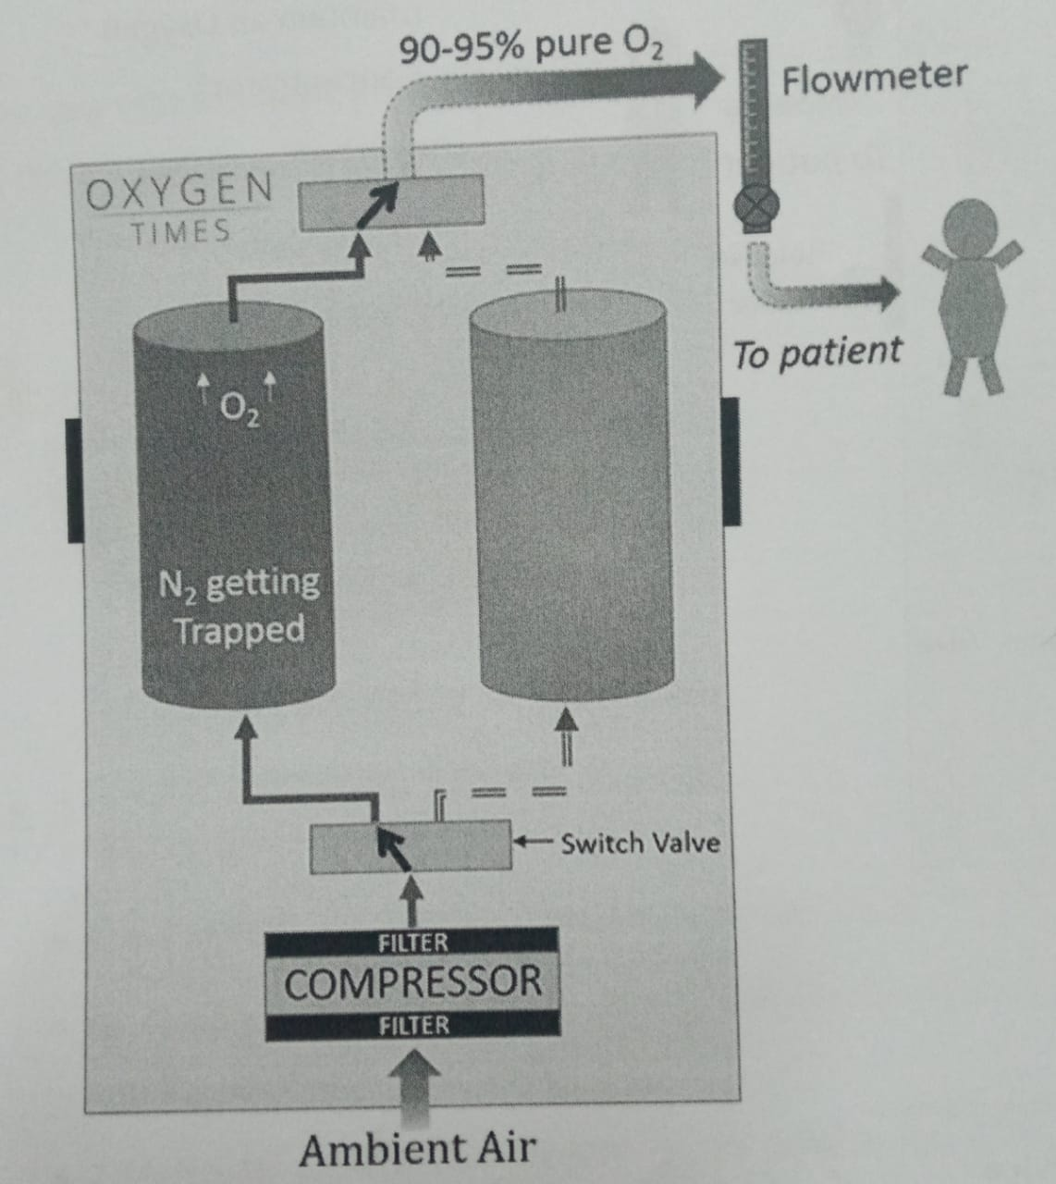
- Now because the air had only nitrogen and oxygen as main components, the primary gas that remains is oxygen. This oxygen has concentration up to 95% and is ready to be supplied to a patient via oxygen delivery system like nasal cannula, oxygen mask etc
- The compressor keeps on compressing air into 1st molecular sieve bed till it gets saturated (filled) with oxygen. The sieve bed usually gets saturated at pressure of 20PSI

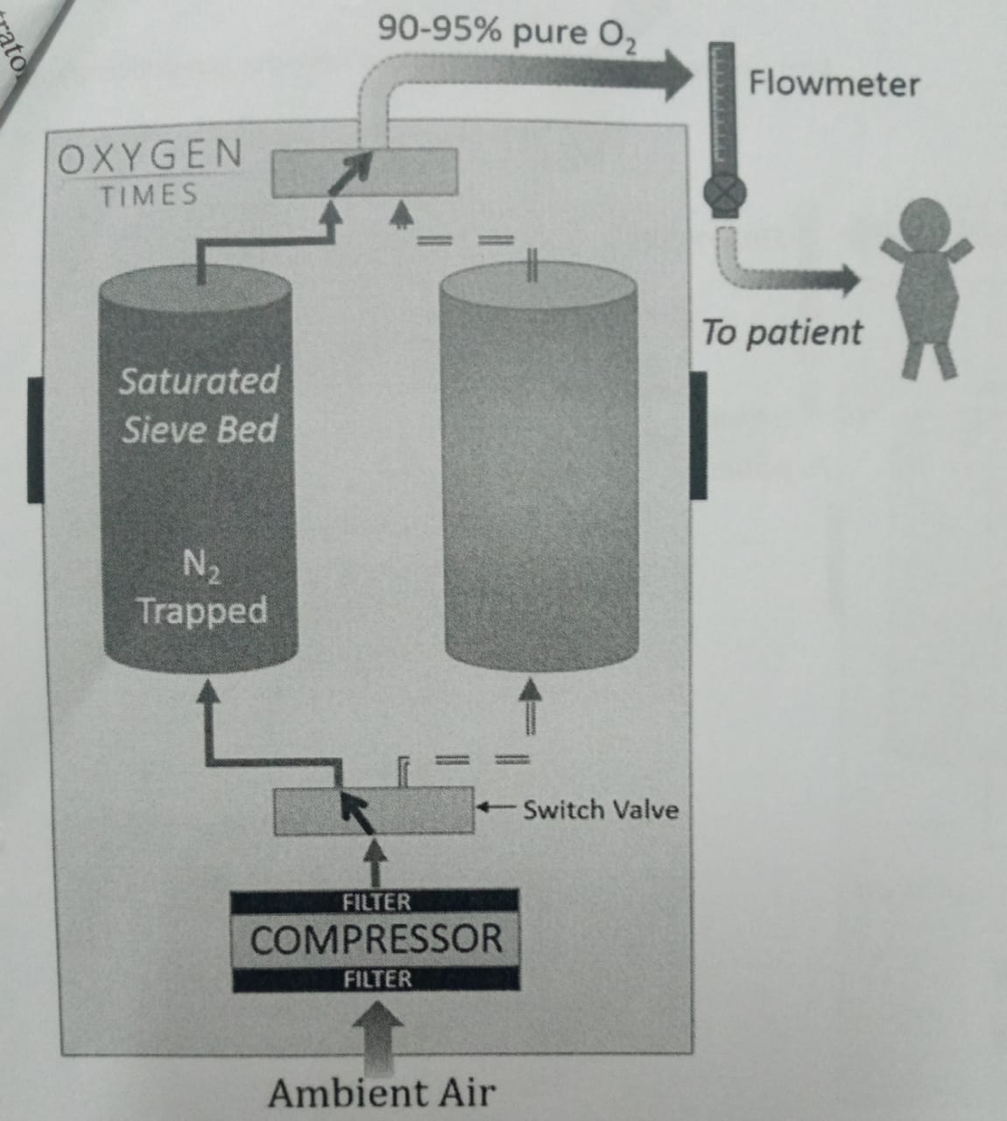
- Just before 1st molecular sieve gets saturated, the switch valve comes into action and output of the air compressor is immediately switched to 2nd molecular sieve bed ie compressor starts compressing air to the 2nd molecular sieve.
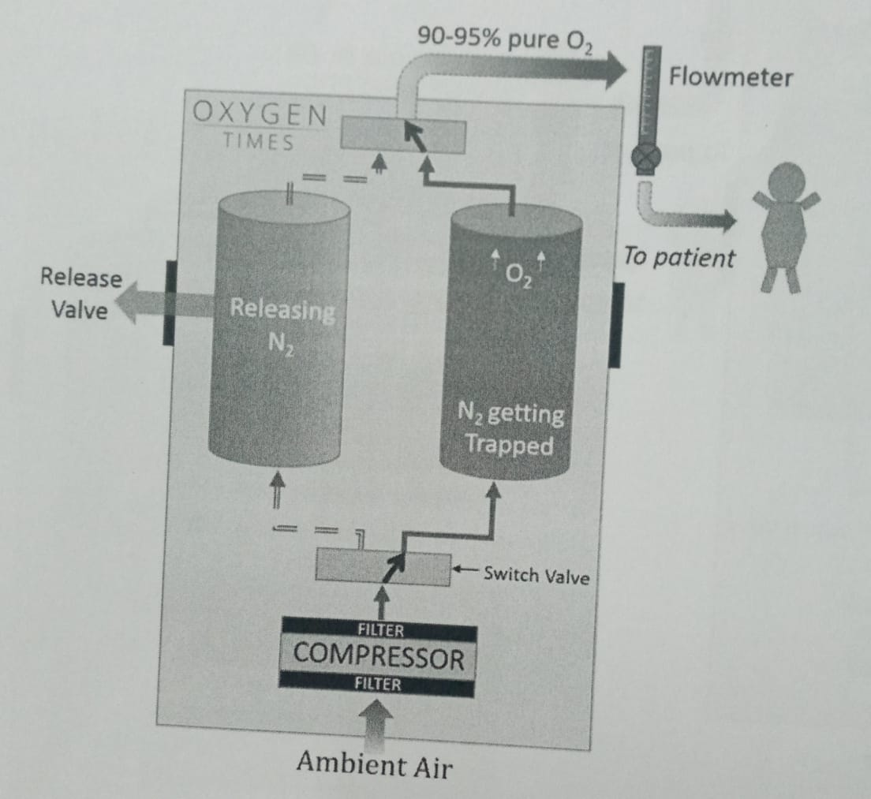

- While this sieve bed gets saturated by nitrogen, the nitrogen that was trapped in the 1st sieve bed is vented out. The little nitrogen that is left in the sieve bed after discharging is removed back – flushing oxygen from other sieve bed.
- The switch valve again switches the output of air compressor back to 1st sieve bed as soon as the 2nd sieve bed approaches saturation.
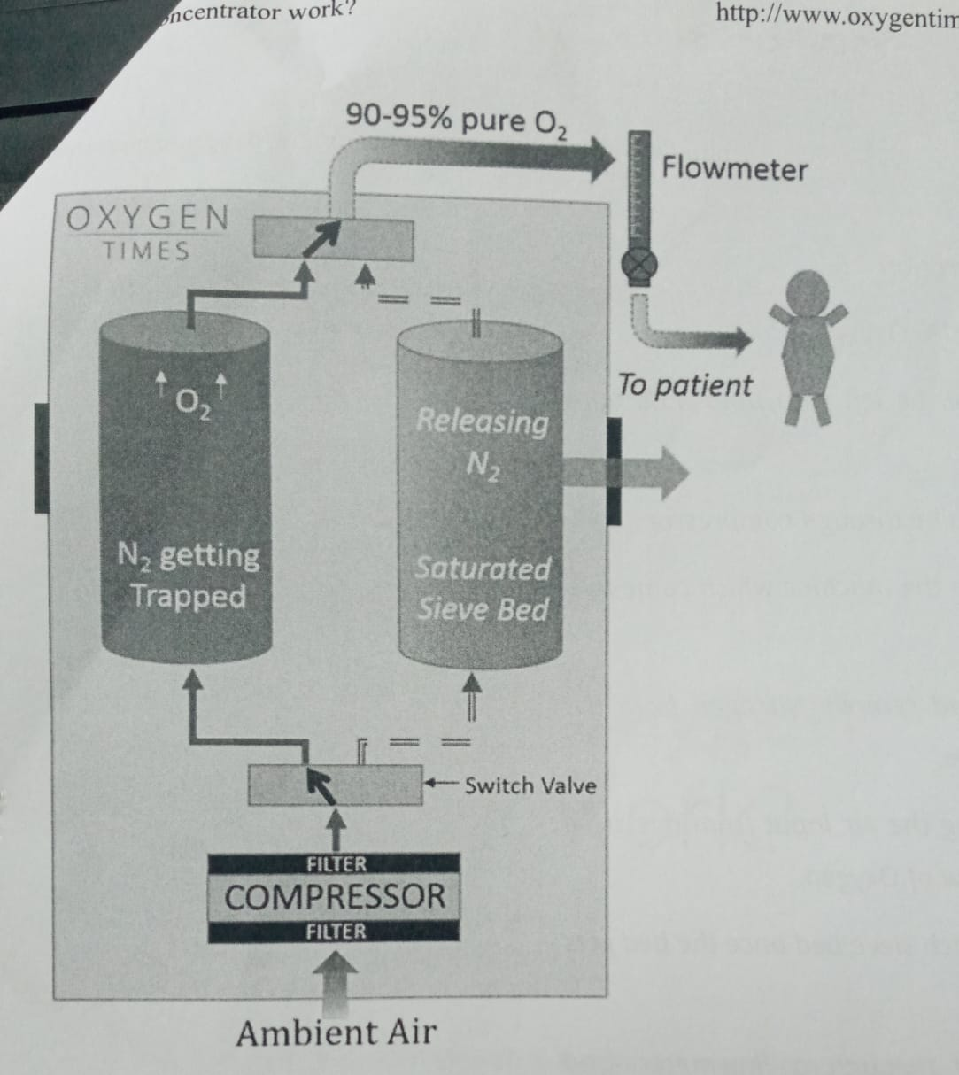

- This process keeps on repeating to ensure continuous flow if oxygen.
- This process of switching the sieve bed is known as Pressure Swing Adsorption (PSA)
- The output of oxygen is then controlled using a flow meter using where the flow can be manually in litres per minute (2 PM)
- Oxygen flows out through an outlet where an oxygen delivery system like nasal cannula or mask is usually connected via humidifier.

Summary on how it works
An oxygen concentrator works much like a window air condition unit, it takes in air modifies it and delivers it in new form. An oxygen concentrator takes in air and purifies it for use by people requiring medical oxygen due to low oxygen level in their blood.
It works by:
- Taking in air from its surroundings
- Compressing air while the cooling mechanism keeps the concentrator from overheating
- Removing nitrogen from the air via filter and sieve beds.
- Adjusting delivery setting with an electronic interface
- Delivering the purified oxygen via a nasal cannula or mask

